**Mockito Hands-On Exercises**

**Exercise 1:** Mocking and Stubbing

Added dependency, code and classes to check

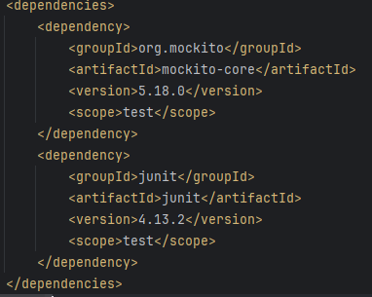

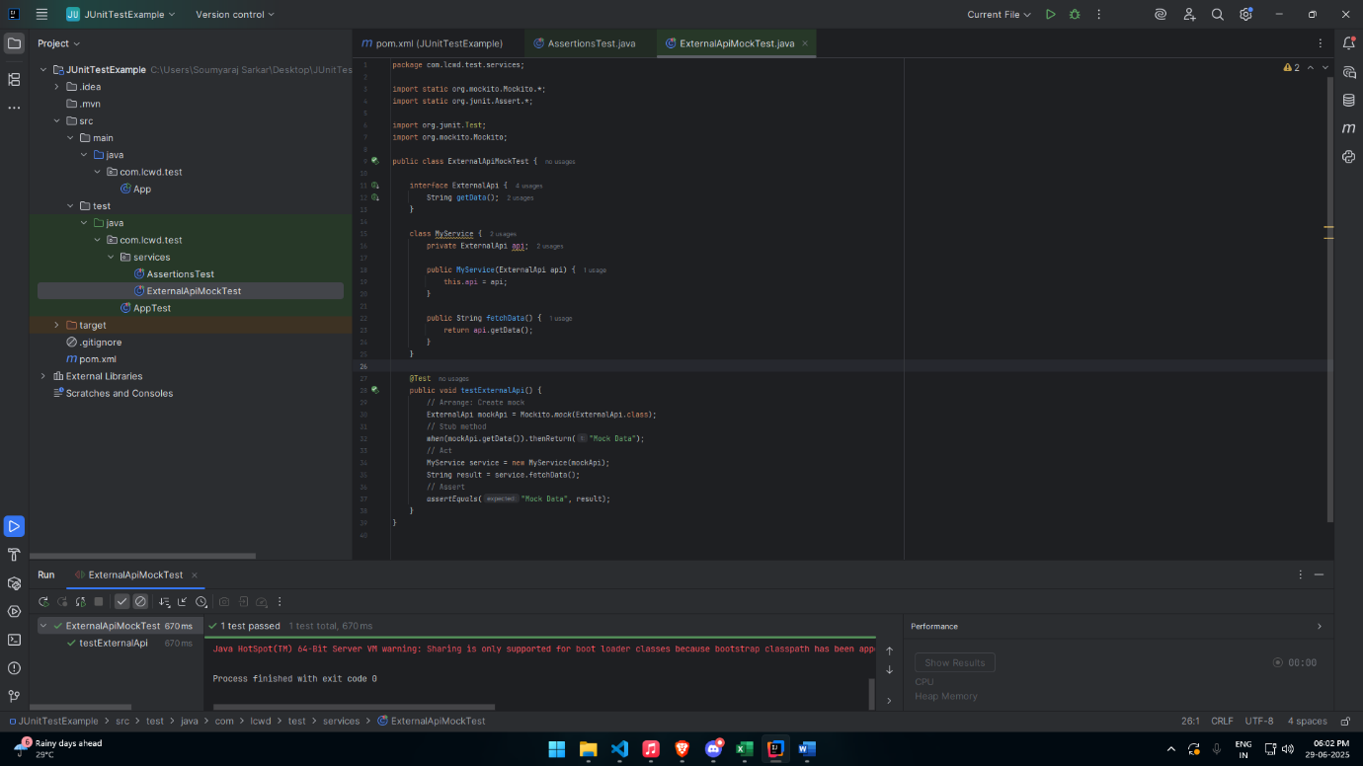

**Exercise 2:** Verifying Interactions

